**CSE4076 IMAGE AND VIDEO ANALYTICS**

**LAB EXPERIMENT-1**

**NAME: Dhaarani Pushpam S**

**REG NO: 21MIA1052**

**GITHUB LINK:** [**https://github.com/DhaaraniPushpam/ImageAndVideoAnalyticsLab_21MIA1052.git**](https://github.com/DhaaraniPushpam/ImageAndVideoAnalyticsLab_21MIA1052.git)

**Lab Task 1: Setup and Basic Extraction**

**Objective:**

Install the necessary tools and libraries, and extract frame information from a video.

**Steps:**

1. **Install ffmpeg and ffmpeg-python**:
   * Install the ffmpeg tool and the ffmpeg-python library.
2. **Extract Frame Information**:
   * Extract frame information from a sample video.

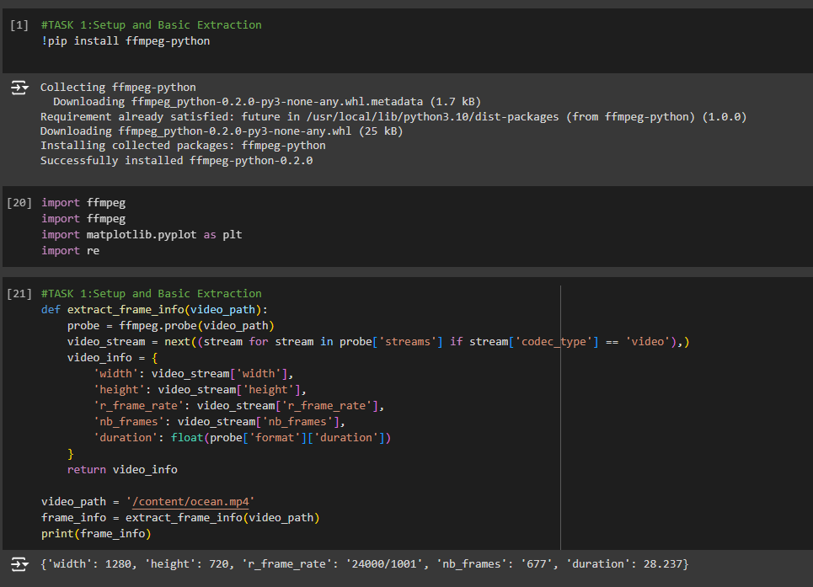

**Lab Task 2: Frame Type Analysis**

**Objective:**

Analyze the extracted frame information to understand the distribution of I, P, and B frames in a video.

**Steps:**

1. **Modify the Script**:
   * Count the number of I, P, and B frames.
   * Calculate the percentage of each frame type in the video.
2. **Analyze Frame Distribution**:
   * Plot the distribution of frame types using a library like matplotlib.
   * Plot a pie chart or bar graph showing the distribution of frame types using matplotlib.

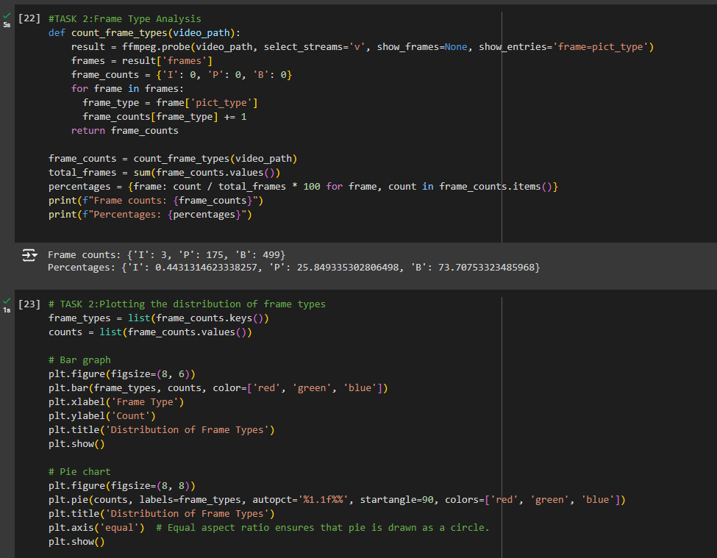

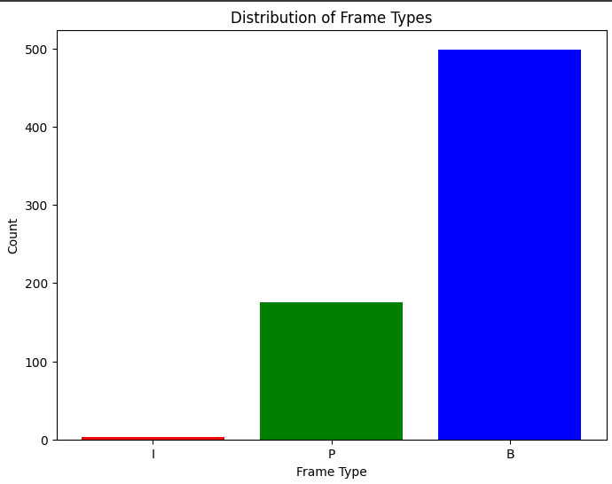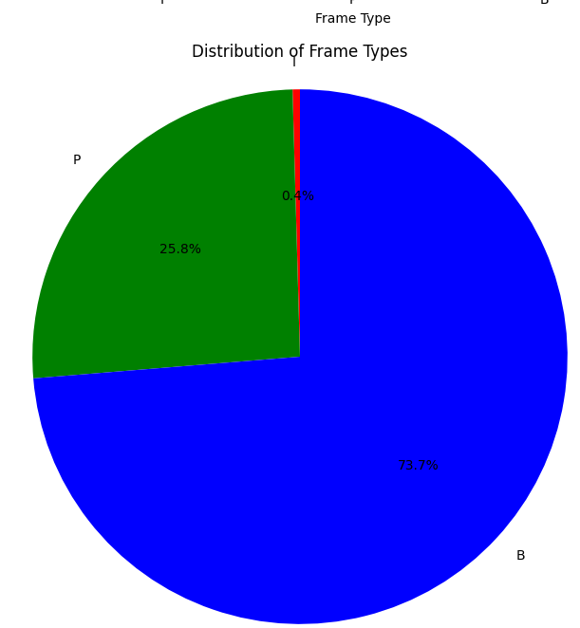

**Lab Task 3: Visualizing Frames**

**Objective:**

Extract actual frames from the video and display them using Python.

**Steps:**

1. **Extract Frames**:
   * Use ffmpeg to extract individual I, P, and B frames from the video.
   * Save these frames as image files.
2. **Display Frames**:
   * Use a library like PIL (Pillow) or opencv-python to display the extracted frames.

**Tasks:**

1. Save I, P, and B frames as separate image files using ffmpeg.
2. Use PIL or opencv-python to load and display these frames in a Python script.
3. Compare the visual quality of I, P, and B frames.

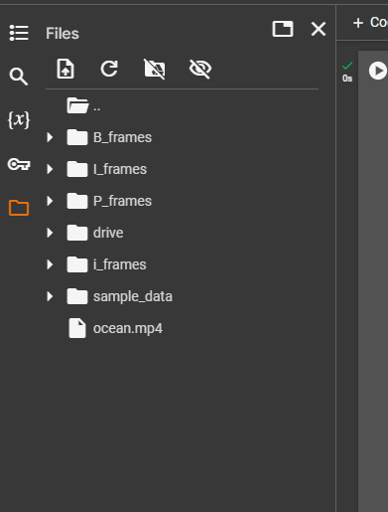 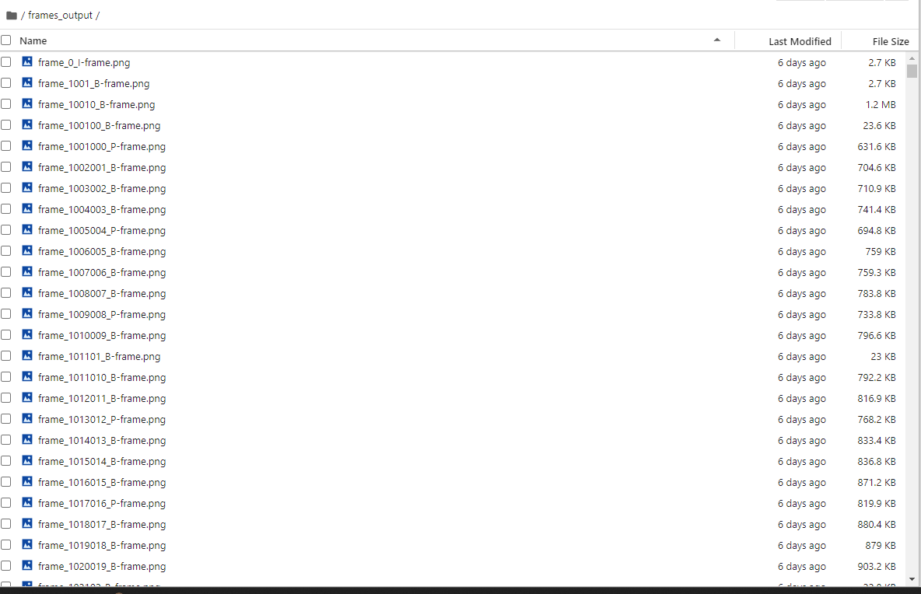

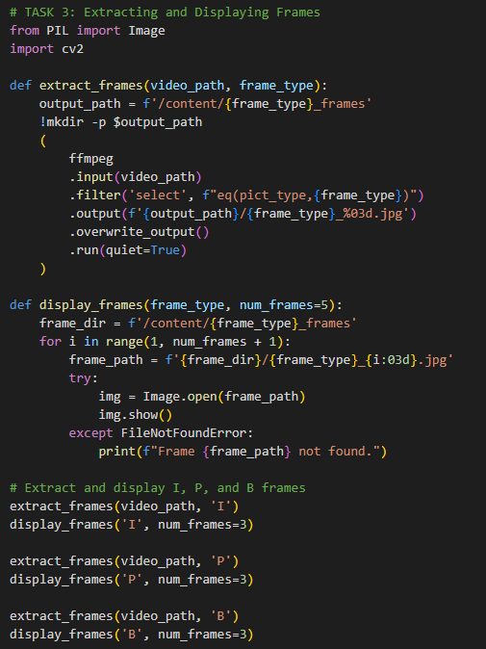

**Lab Task 4: Frame Compression Analysis**

**Objective:**

Analyze the compression efficiency of I, P, and B frames.

**Steps:**

1. **Calculate Frame Sizes**:
   * Calculate the file sizes of extracted I, P, and B frames.
   * Compare the average file sizes of each frame type.
2. **Compression Efficiency**:
   * Discuss the role of each frame type in video compression.
   * Analyze why P and B frames are generally smaller than I frames.

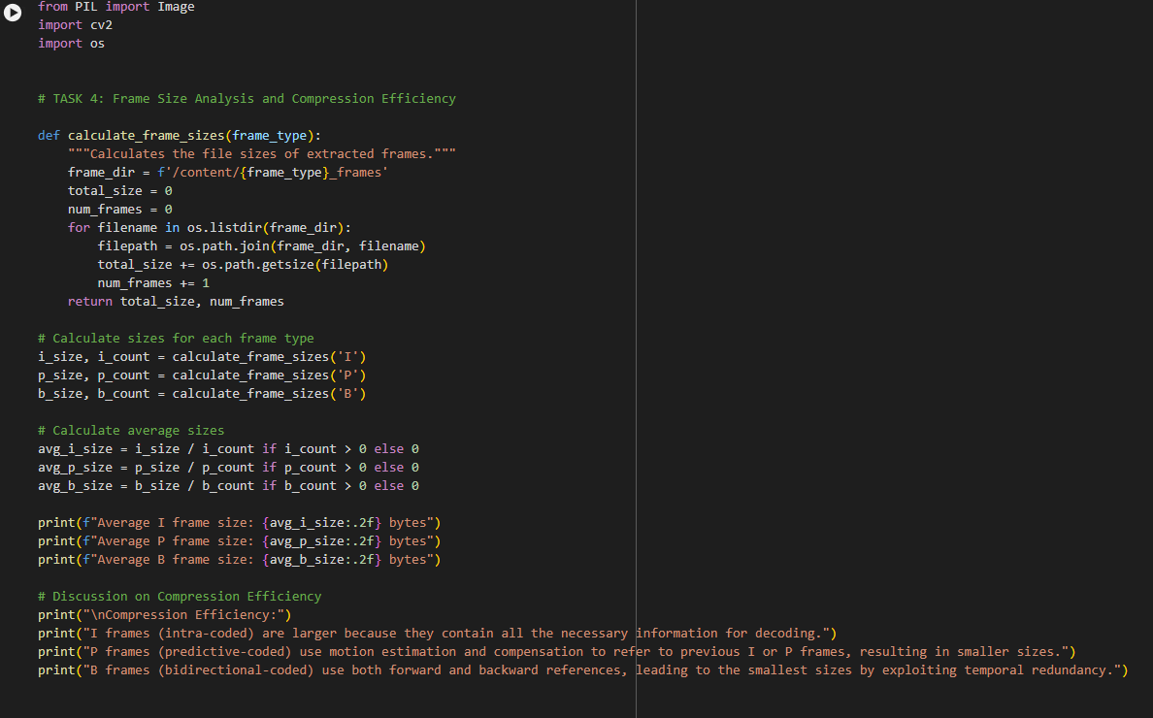

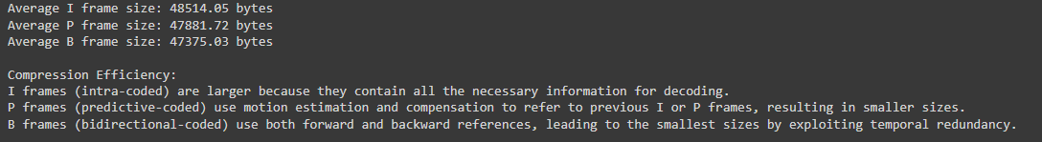

**Lab Task 5: Advanced Frame Extraction**

**Objective:**

Extract frames from a video and reconstruct a part of the video using only I frames.

**Steps:**

1. **Extract and Save I Frames**:
   * Extract I frames from the video and save them as separate image files.
2. **Reconstruct Video**:
   * Use the extracted I frames to reconstruct a portion of the video.
   * Create a new video using these I frames with a reduced frame rate.

